





A Project Report Is Based On:
Professional Photographer Booking : One Click, Perfect Memories! (Semester-V Bachelor Of computer Application)

Internal Guide: Shailee Shah
Website: https:/ / pica.shayonainstitute.edu.in

Developed By:
- Om Soni A. (Roll No. – 5005)
- Dhruv Khandwala H. (Roll No. – 5012)
- Mishva Mistry B.(Roll No. – 5041)



Index

- Company Profile
- Project Definition
- Tools & Technology
- Existing System
- Proposed System
- Modules Of The System
- UML Diagrams
- UseCase Diagram
- Activity Diagram
- Sequence Diagram
- Class Diagram
- E-R Diagram
- Data Dictionary


COMPANY PROFILE


Company Name | Xorbyte Solution
Company Email | contact@xorbytesolution.com
Contact No | 70962 21661
External Guide
Address | 3rd Floor, 304, Ramchandra House, Textile Tech Society, near Dinesh Hall, Shreyas Colony, Navrangpura, Ahmedabad, Gujarat 380009
Website | www.xorbytesolution.com



PROJECT
PROFILE
Project Name : Professional Photographer Booking

Objective : The objective of the photographer booking system is to simplify the process of finding and booking photographers for specific occasion.

Group No. : 12

Group Members : 3

Team Members : Om Soni, Dhruv Khandwala, Mishva Mistry.

TOOlS

Pycharm
Draw.io Diagrammaking
.

Web Browser like Chrom
.

Db Browser For Sqllite
.









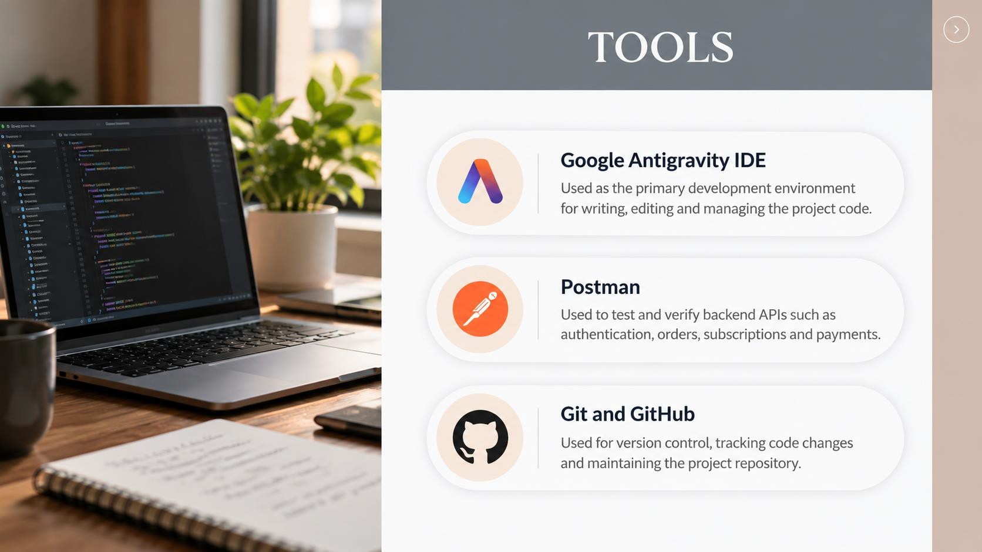

14

TECHNOLOGY

Frontend: Backend:

HTML
to create a structure of web pages like if we want to create buttons.
PYTHON
python with django framework .

CSS
to style web pages. Like adding colors, effects, positions of elements..

JAVASCRIPT
to create events like triggers or validations. Like onClick of a button.
SQLITE
For database


















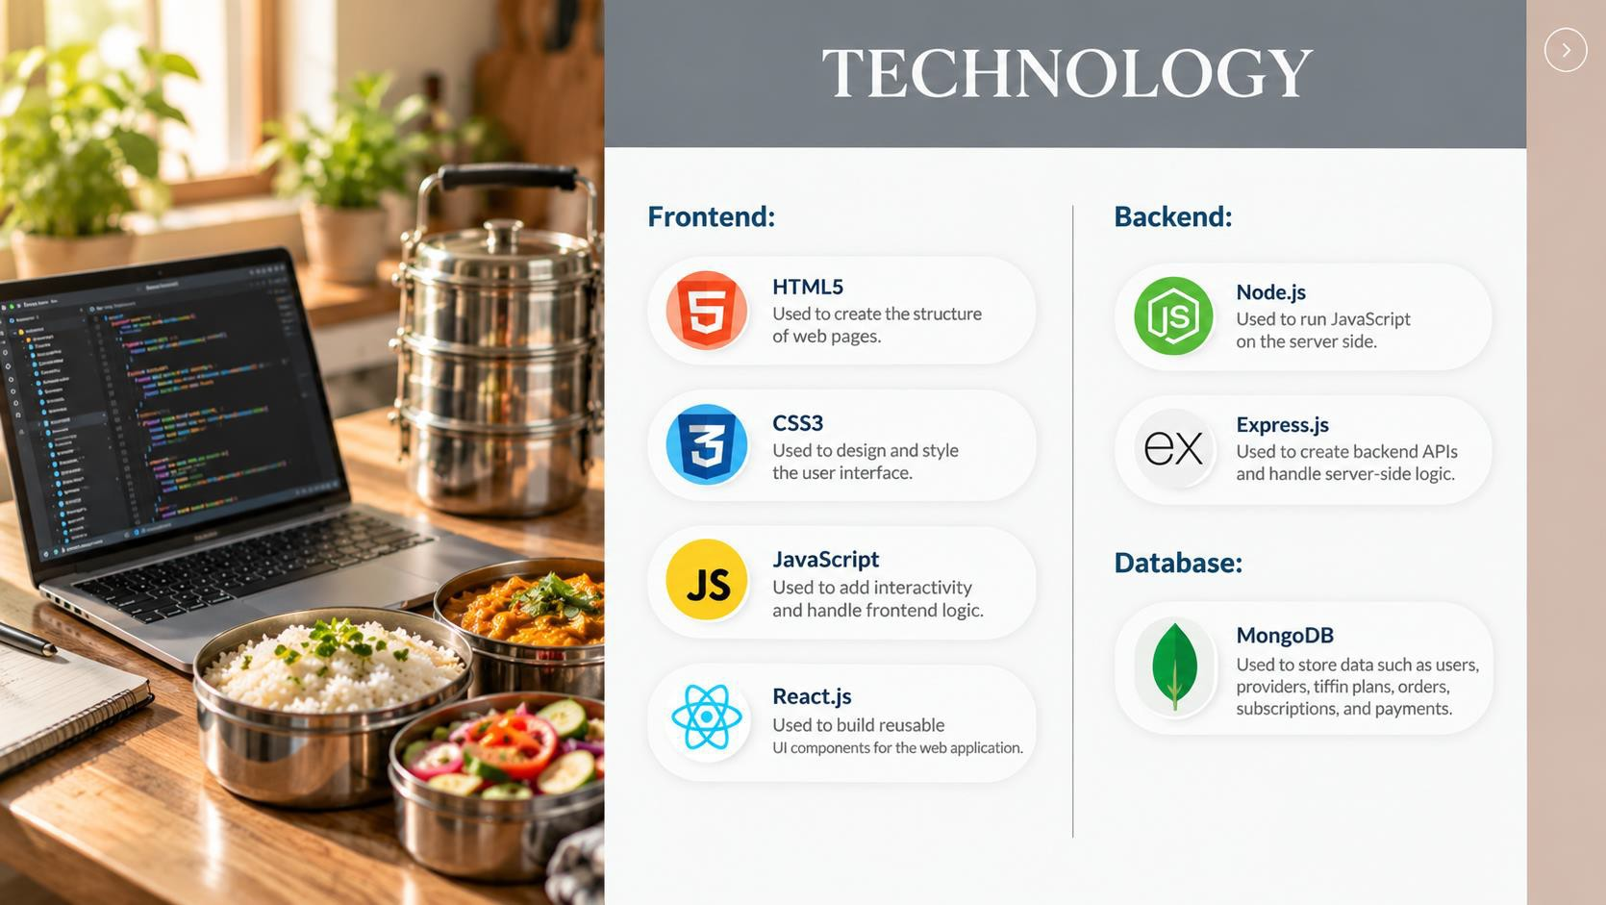

BOOTSTRAP
to make web pages responsive.

14



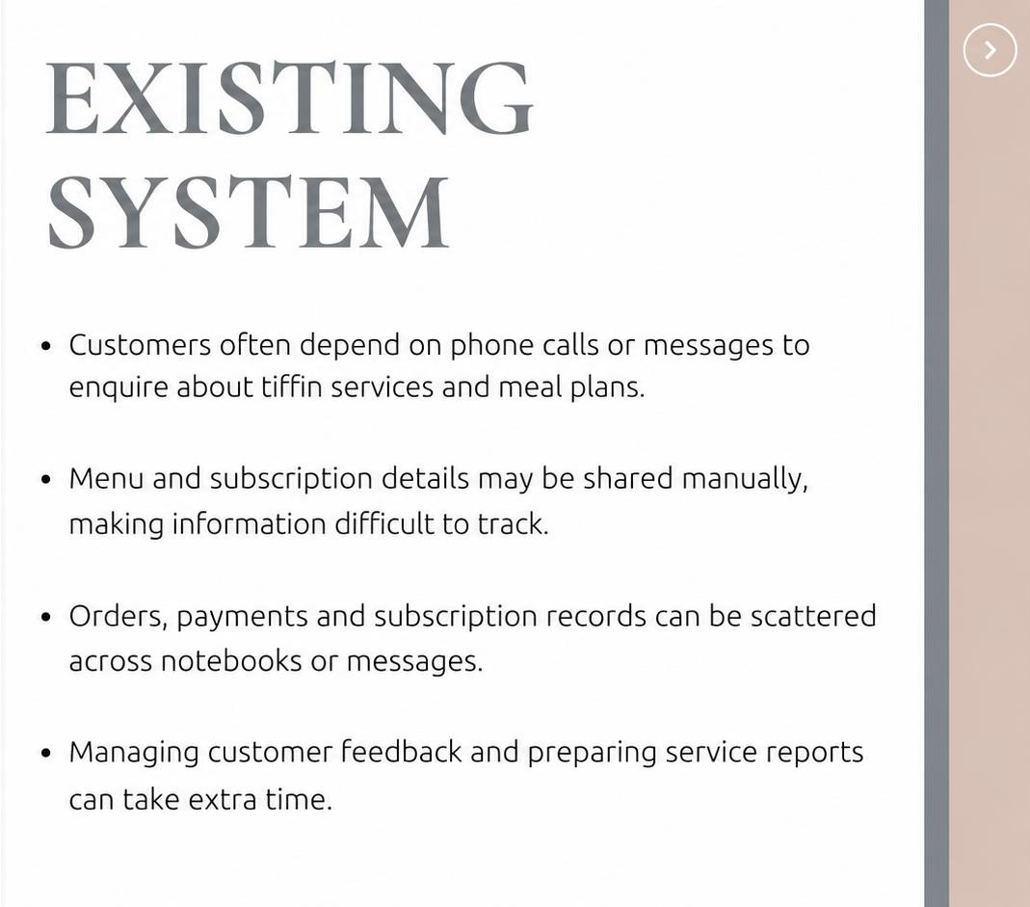
EXISTINNG SYSTEM
- Confusing booking process that causes clients to leave without
scheduling.

- Limited customization options for services.

- Calendar mix-ups leading to double bookings.

- Complicated payment processing


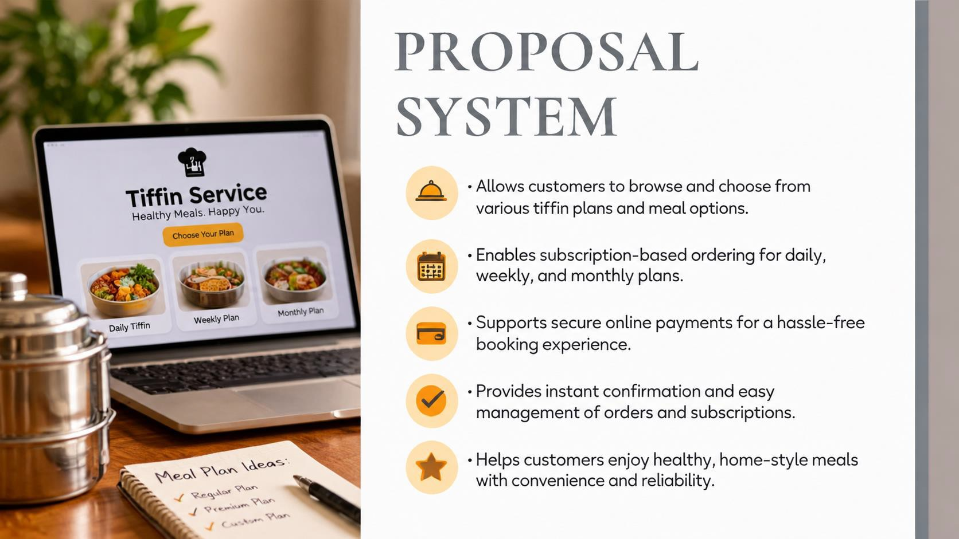
PROPOSED SYSTEM

- Easy online booking process that simplifies scheduling for clients.

- Flexible customization options for services and bookings.

- Automatic calendar updates to avoid double bookings.

- Easy payment options for booking with multiple choices.

- Simple feedback process for clients to share their opinions.

- Friendly customer support ready to assist with any questions or issues.

PROJECT MODULES

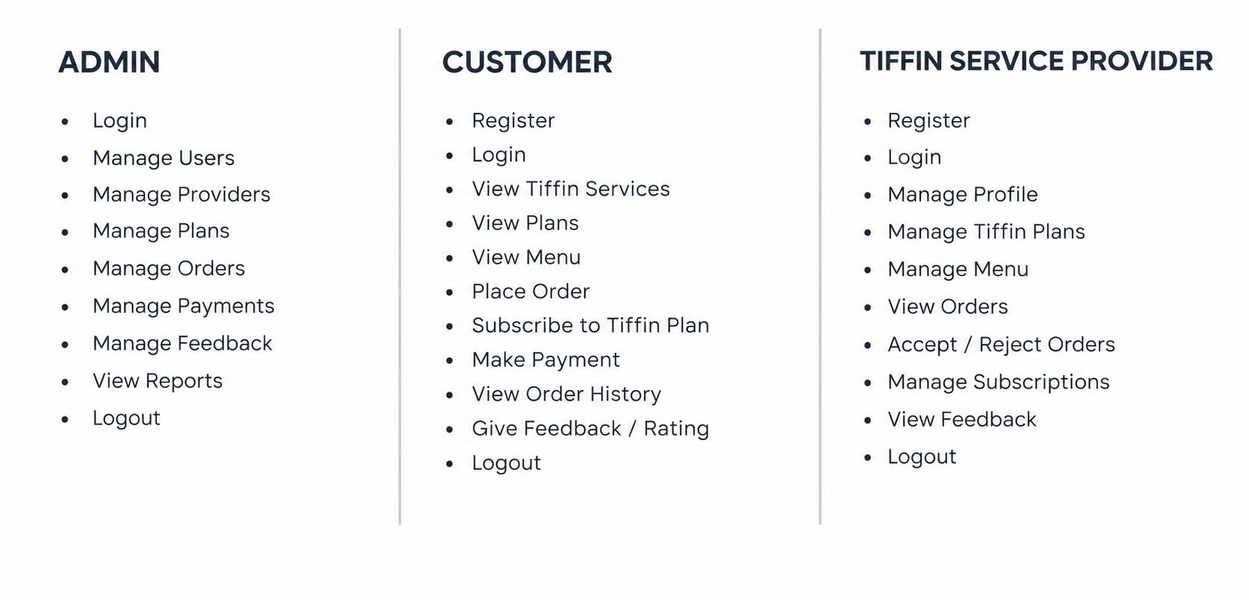

UML DIAGRAM

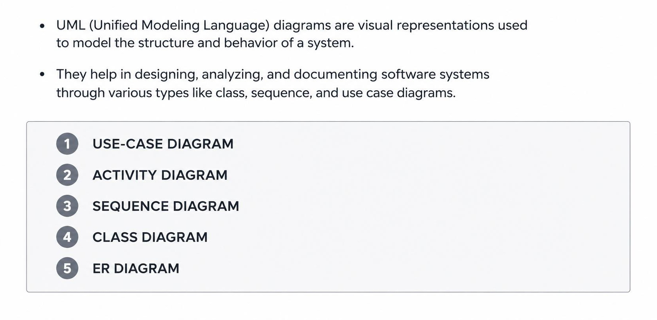

USECASE-DIAGRAM COMPONENTS AND NOTATIONS

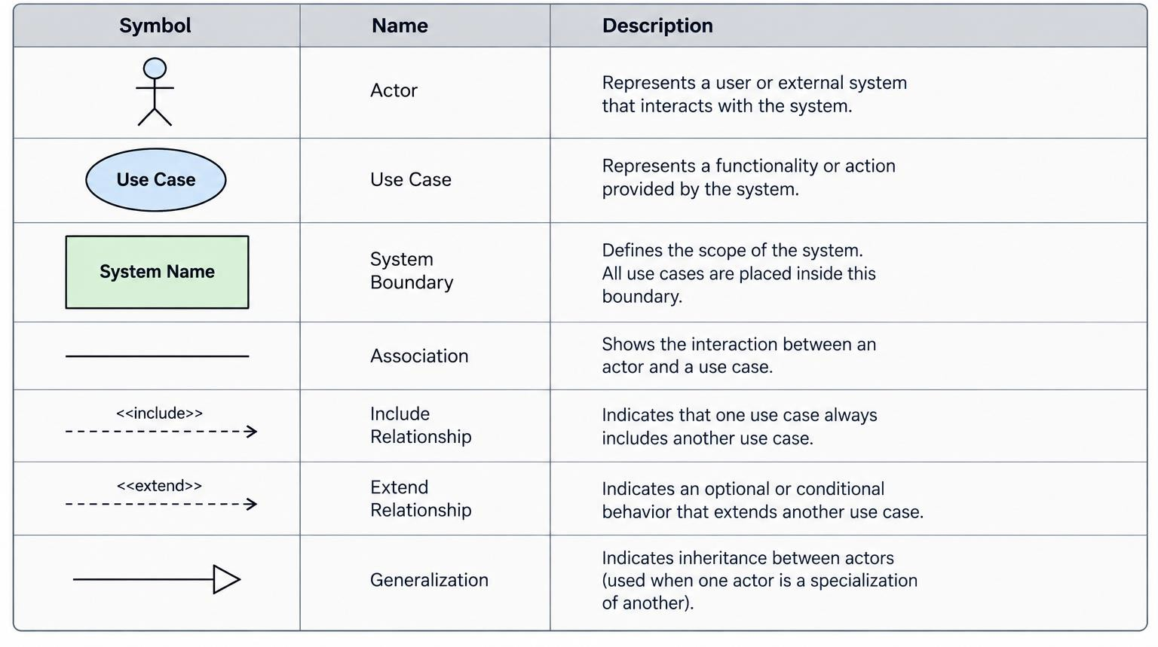

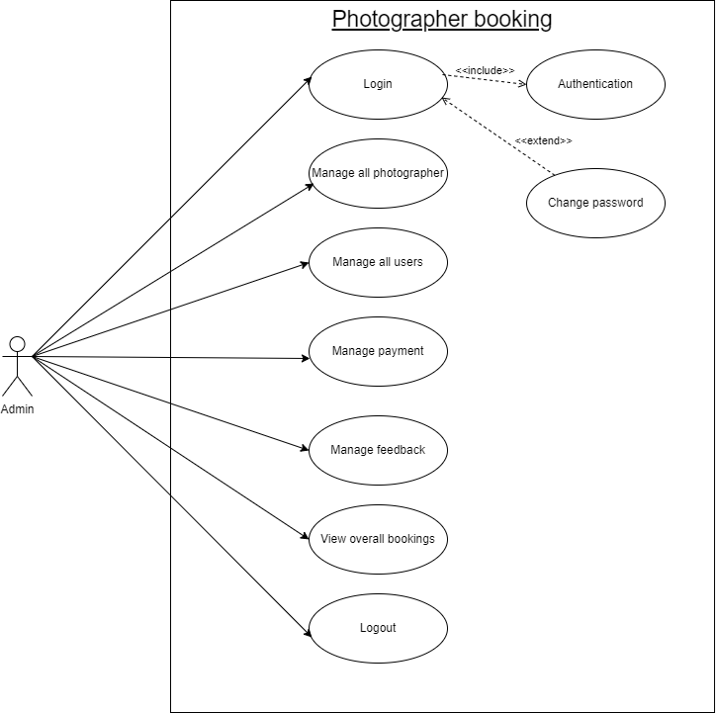
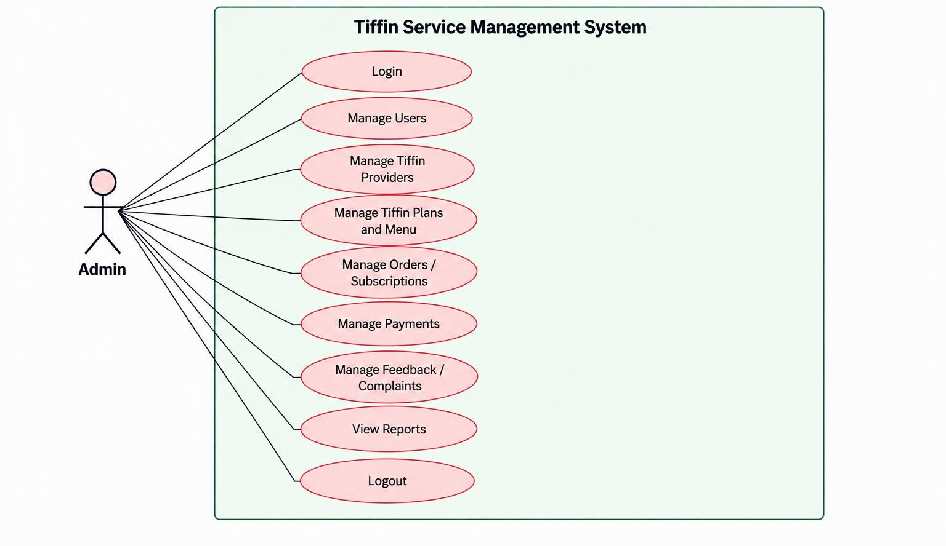
USECASE FOR ADMIN SIDE

USECASE FOR USER SIDE

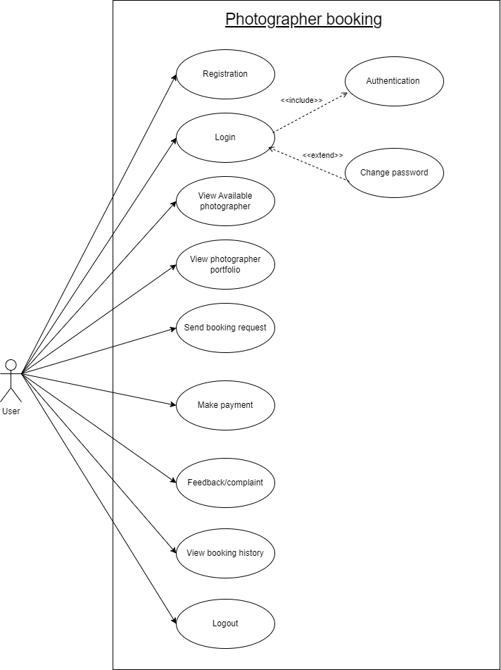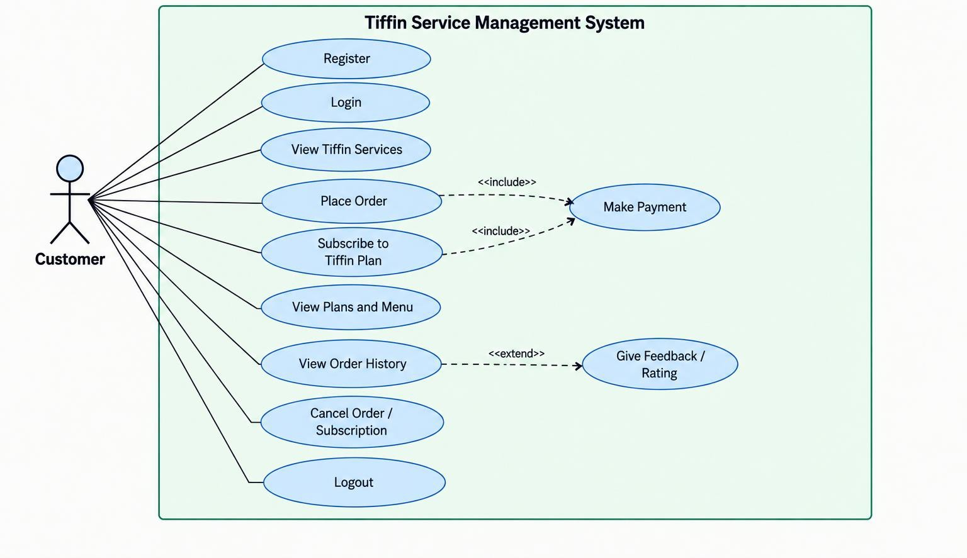

USECASE FOR TIFFIN SERVICE PROVIDER

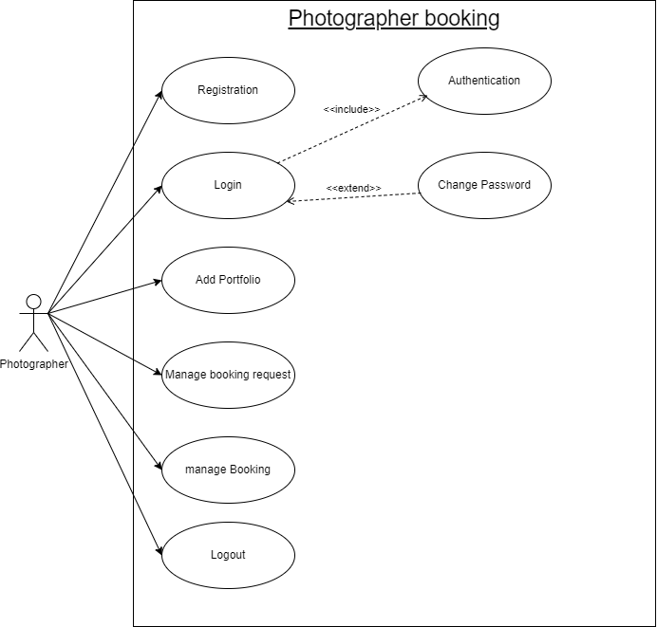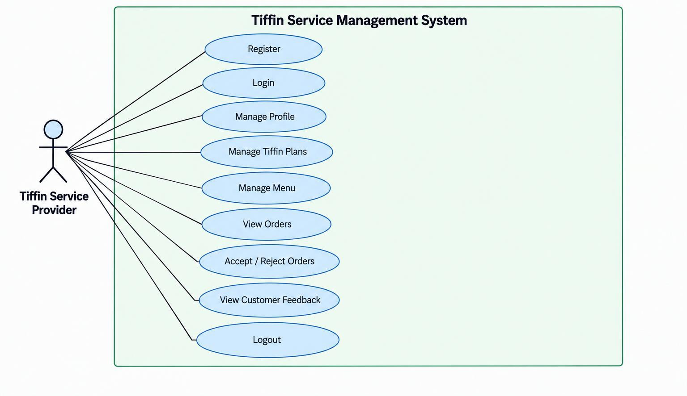

ACTIVITY-DIAGRAM COMPONENTS AND NOTATIONS

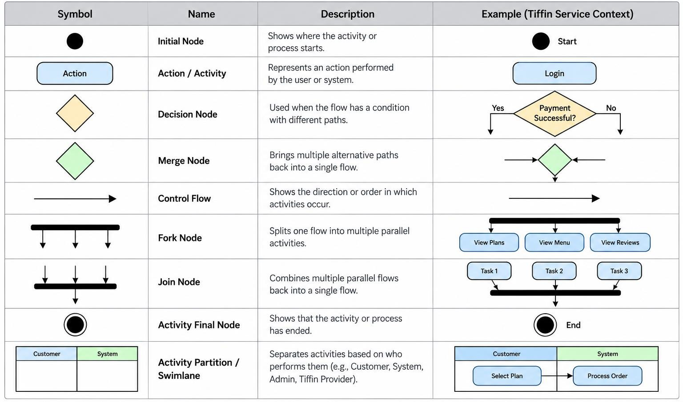

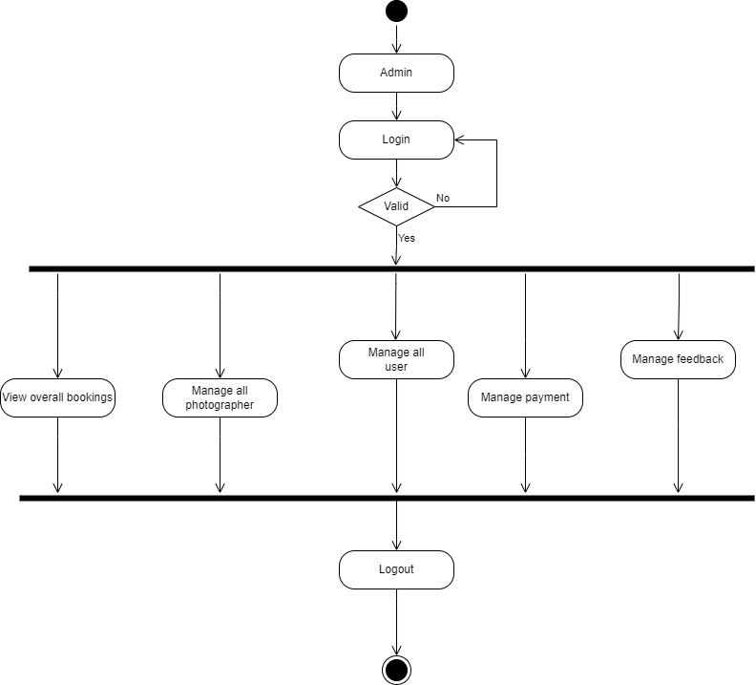
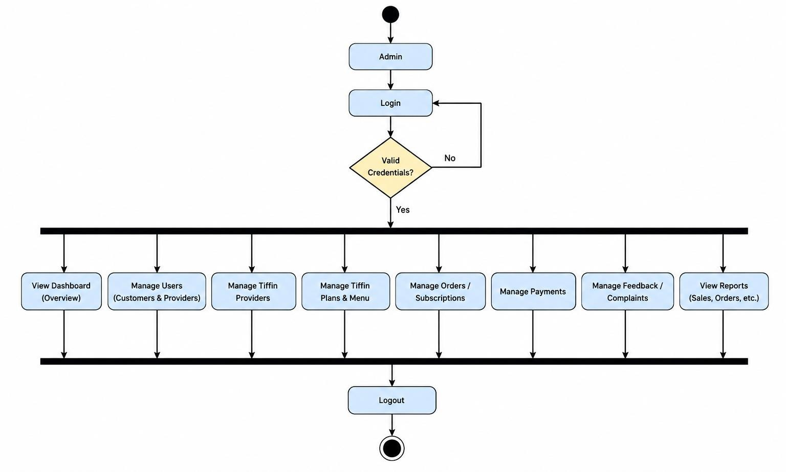
ACTIVITY FOR ADMIN SIDE

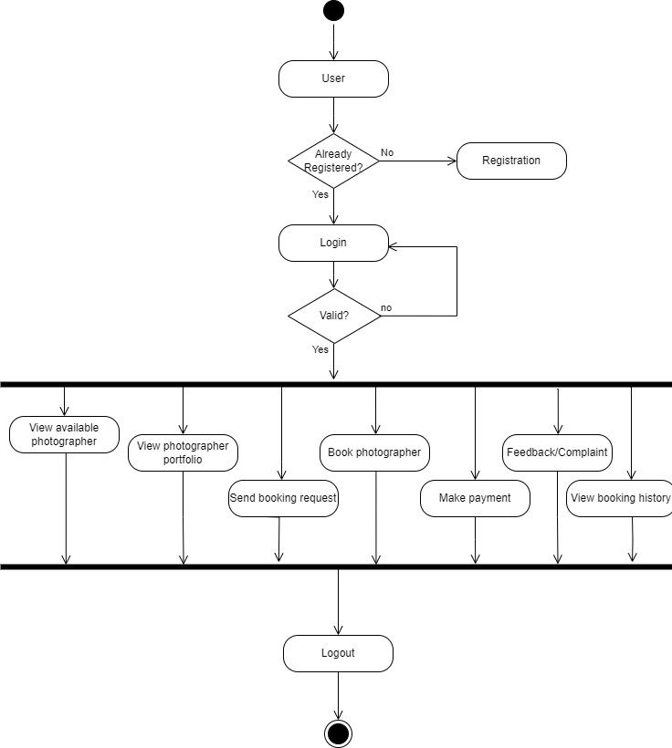
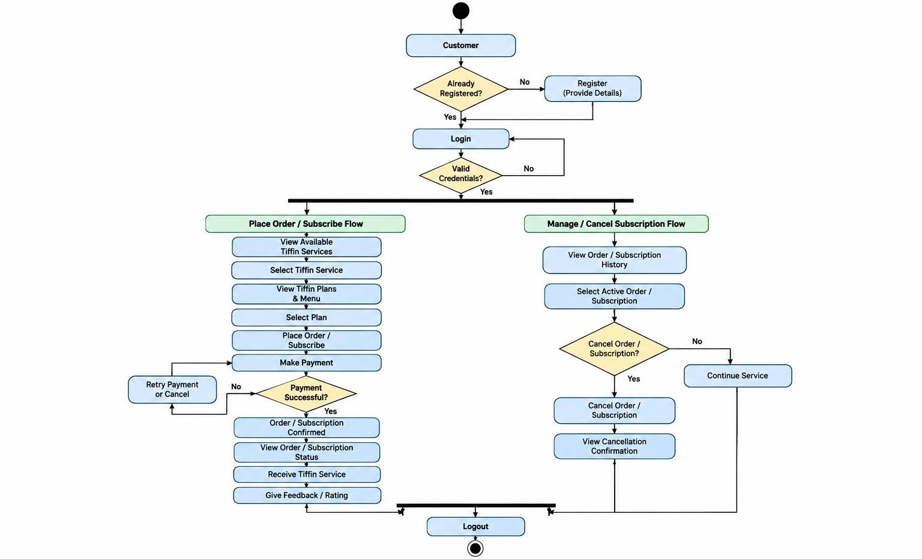
ACTIVITY FOR USER SIDE

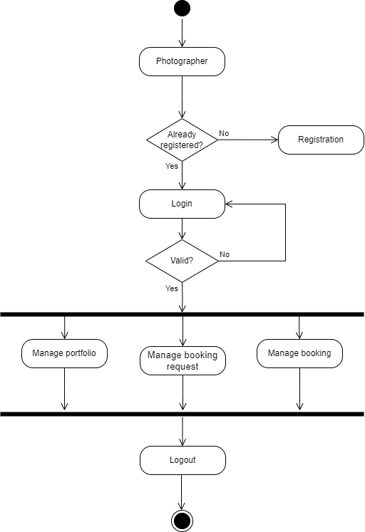
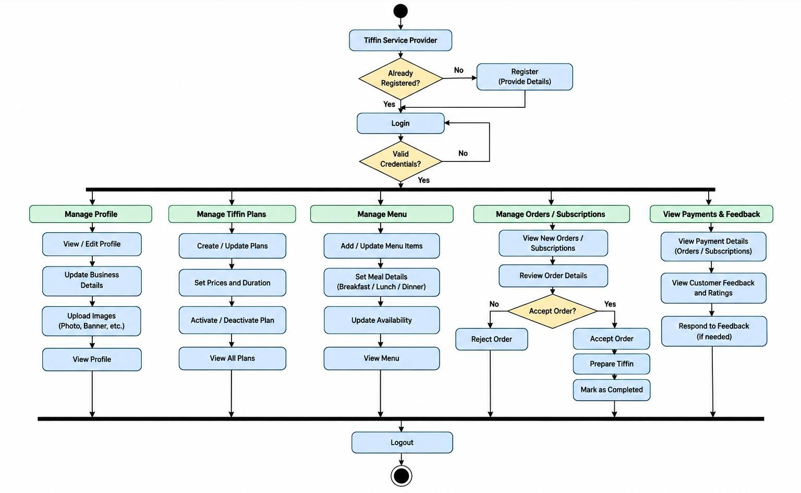
ACTIVITY FOR TIFFIN SERVICE PROVIDER

SEQUENCE-DIAGRAM COMPONENTS AND NOTATIONS

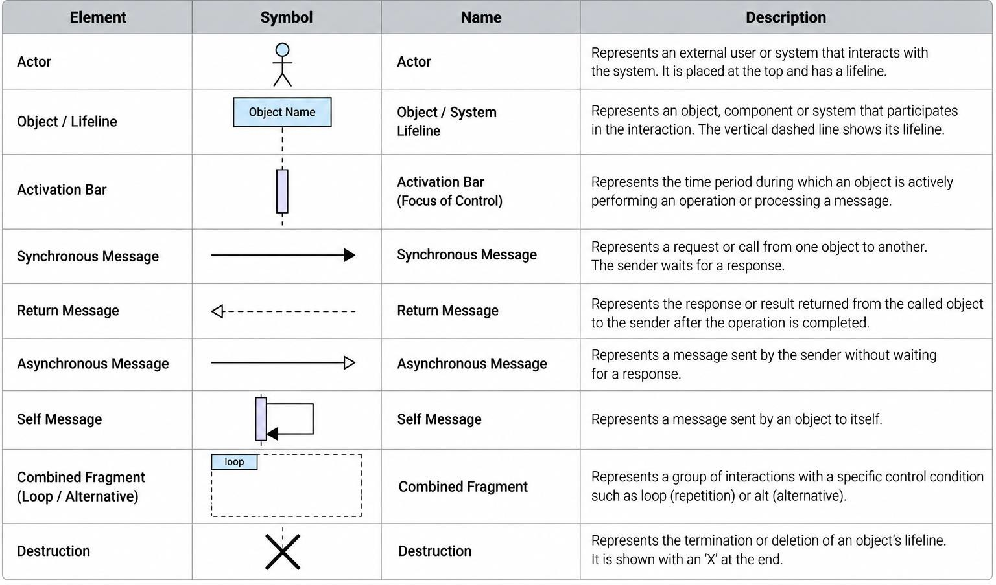

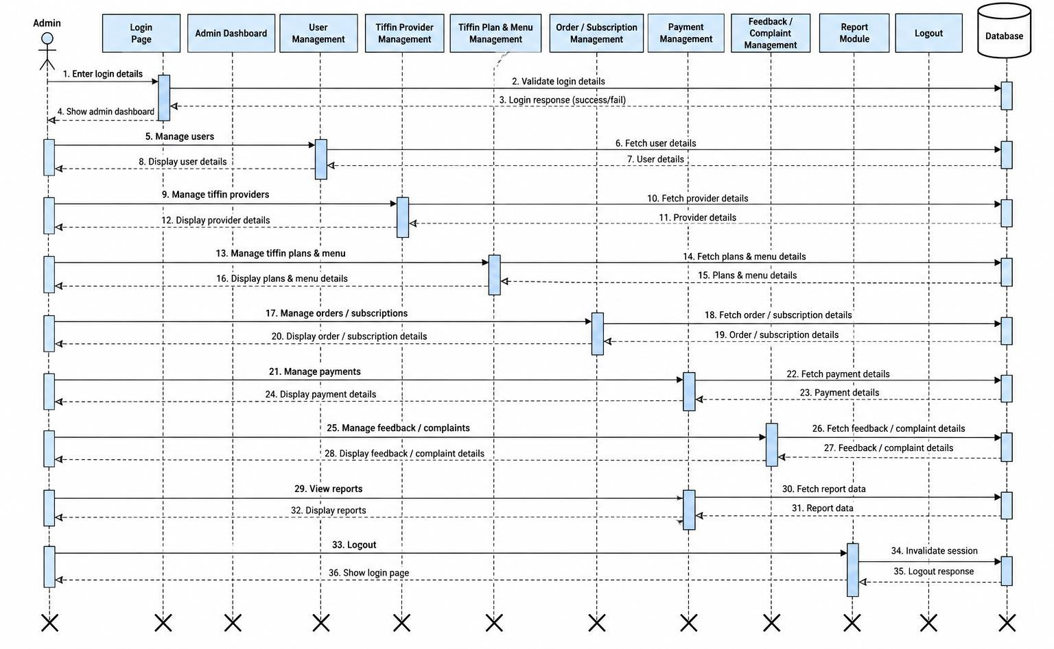
SEQUENCE FOR ADMIN SIDE

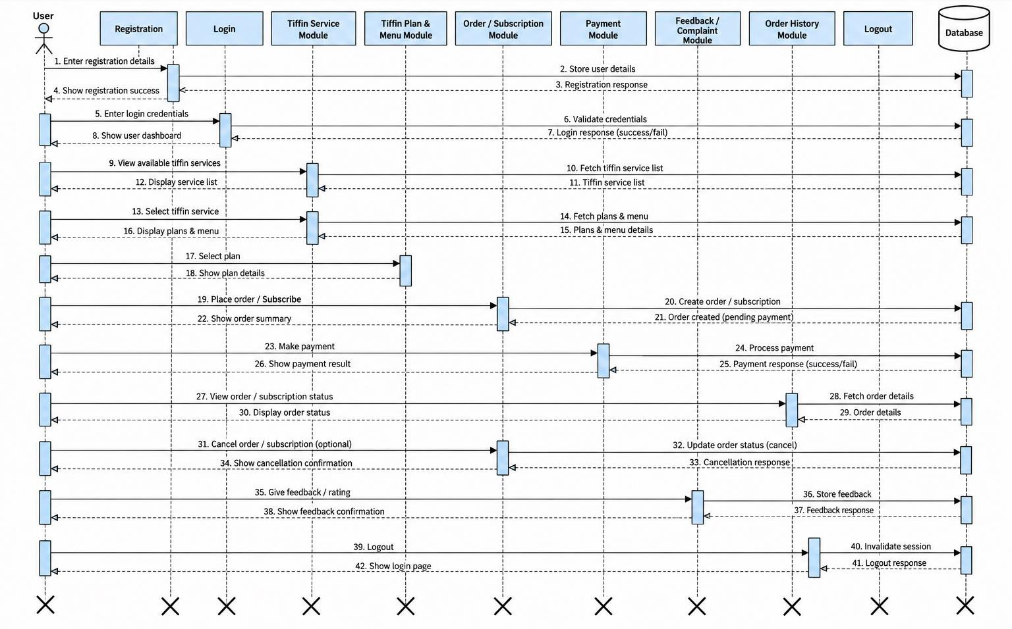
SEQUENCE FOR USER SIDE

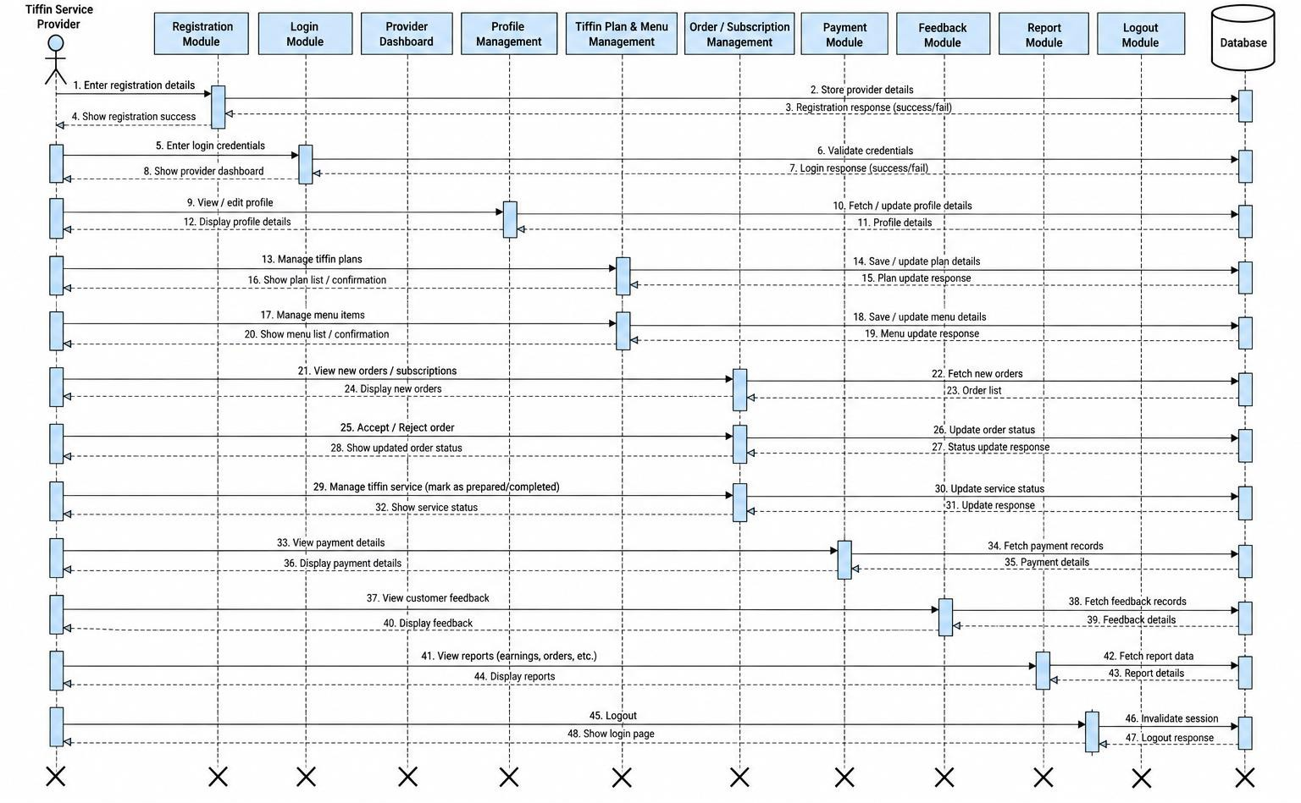
SEQUENCE FOR TIFFIN SERVICE PROVIDER

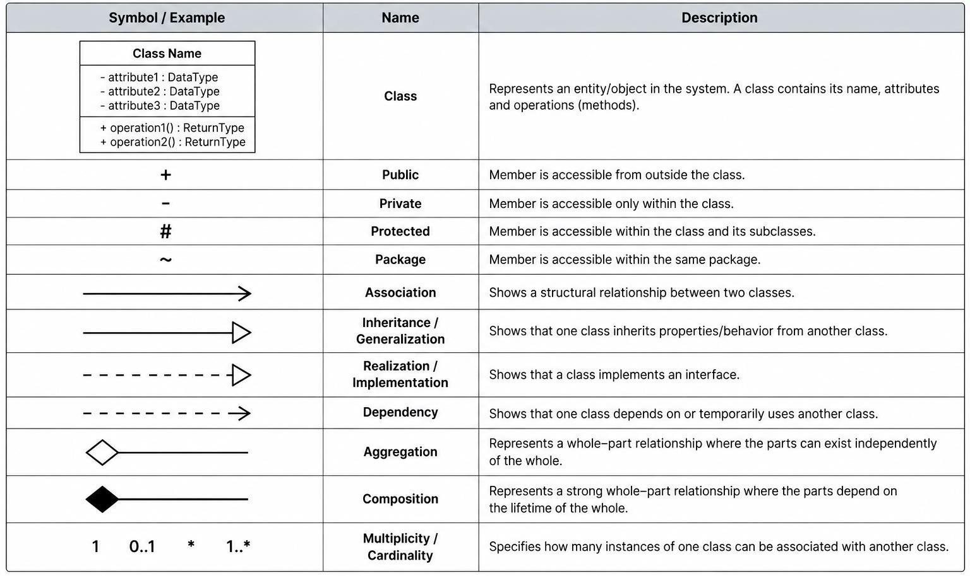
CLASS-DIAGRAM COMPONENTS AND NOTATIONS

CLASSDIAGRAM

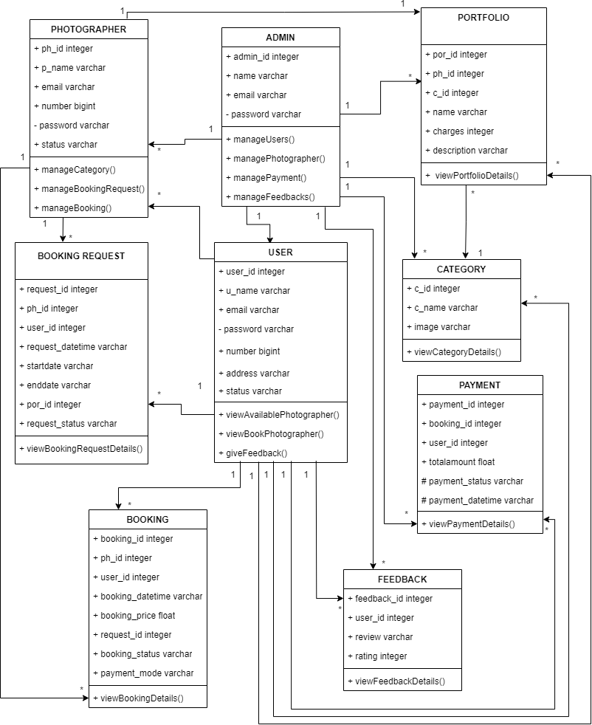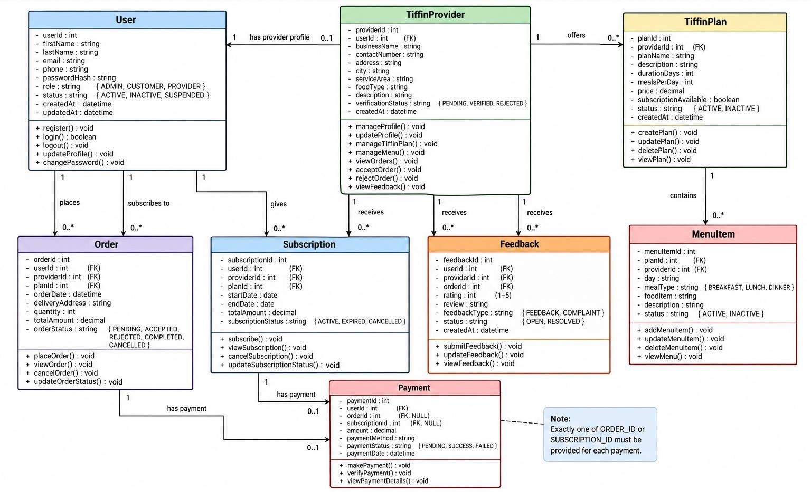

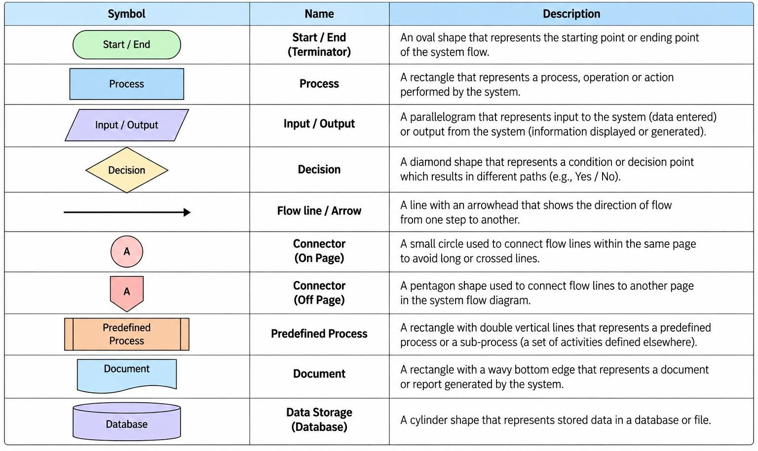
SYSTEM-FLOW DIAGRAM COMPONENTS AND NOTATIONS

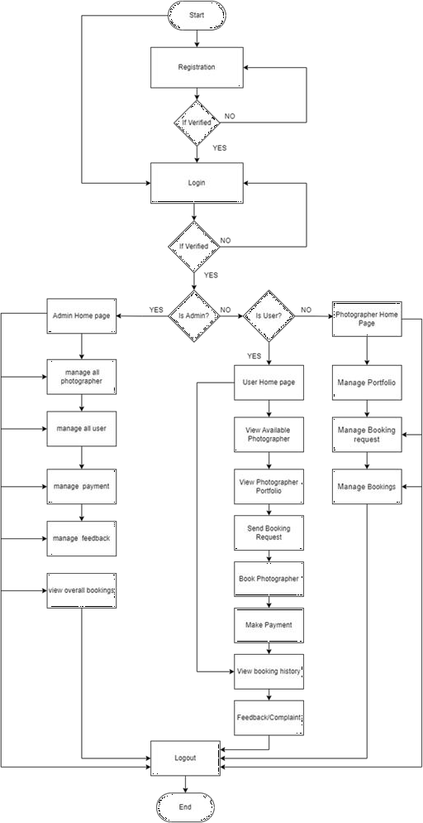
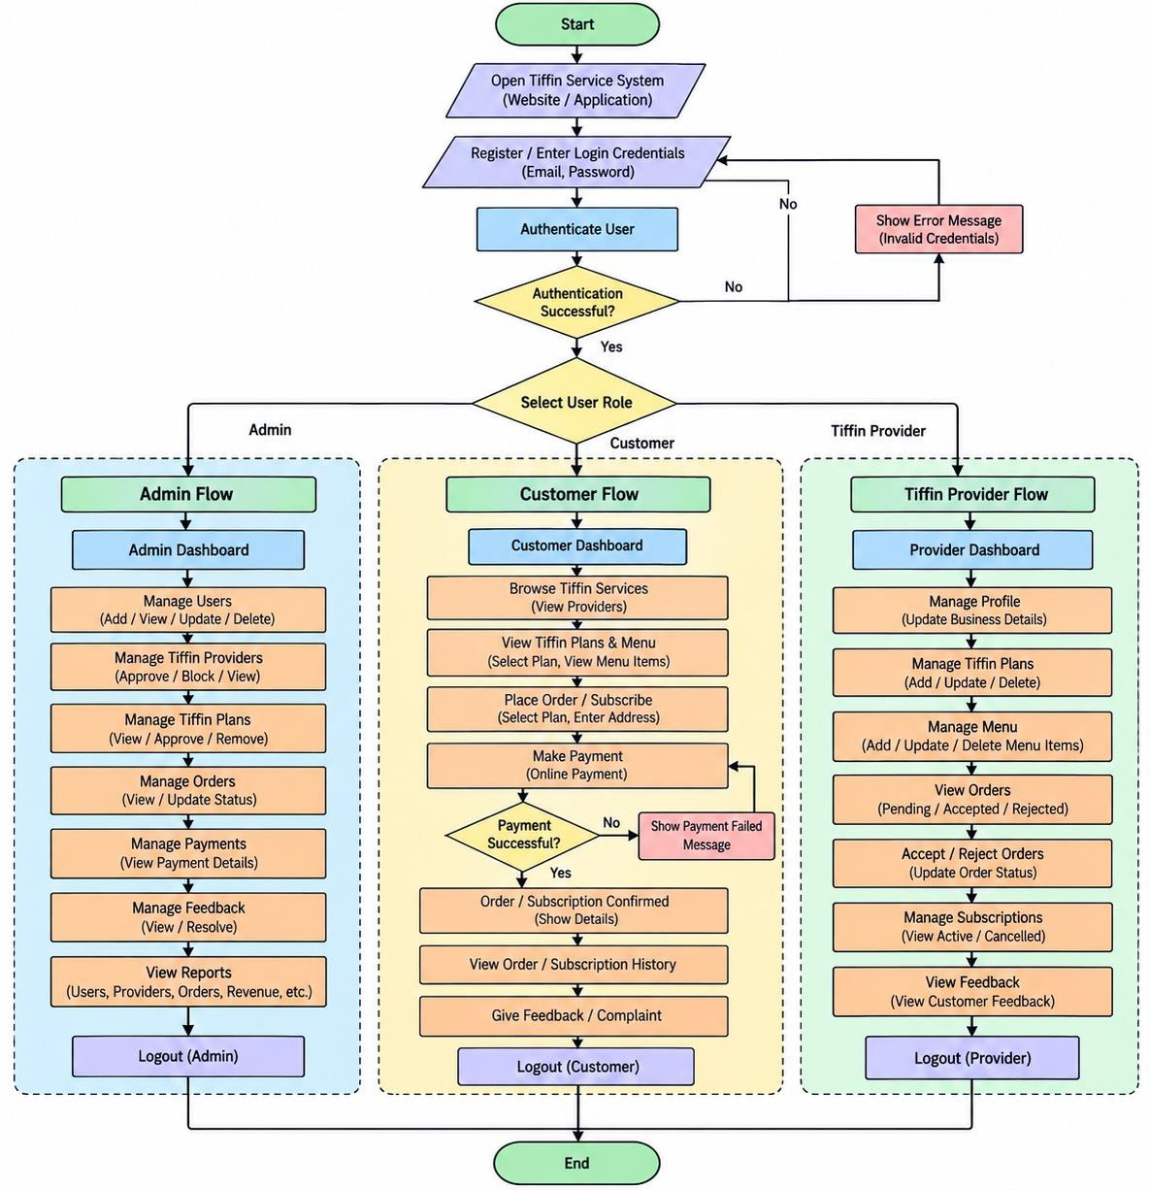
SYSTEM FLOW DIAGRAM

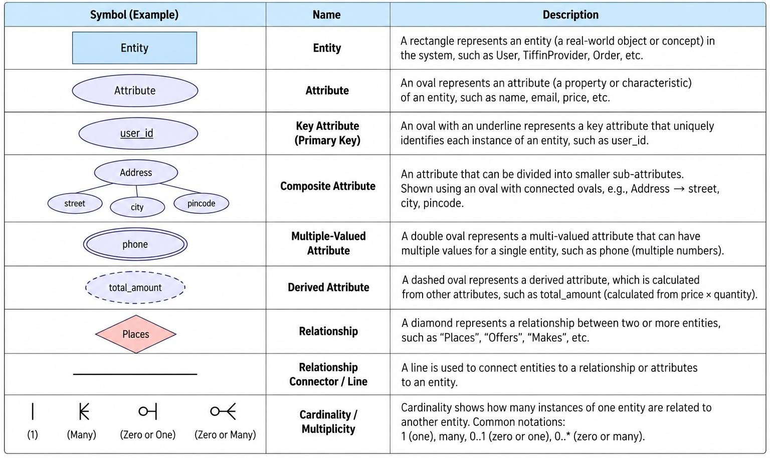
ER-DIAGRAM COMPONENTS AND NOTATIONS

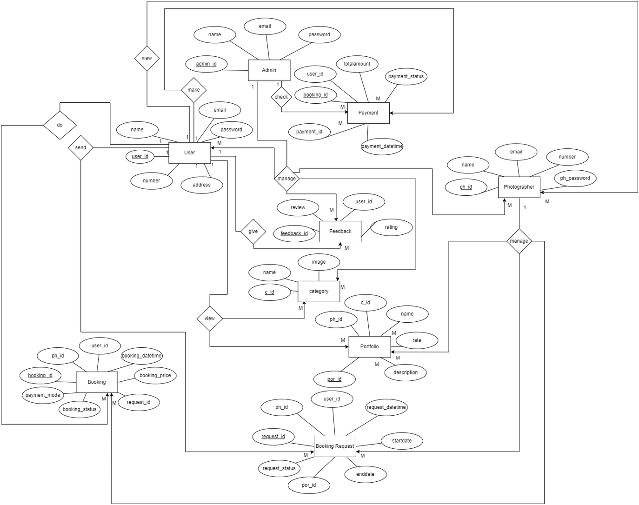
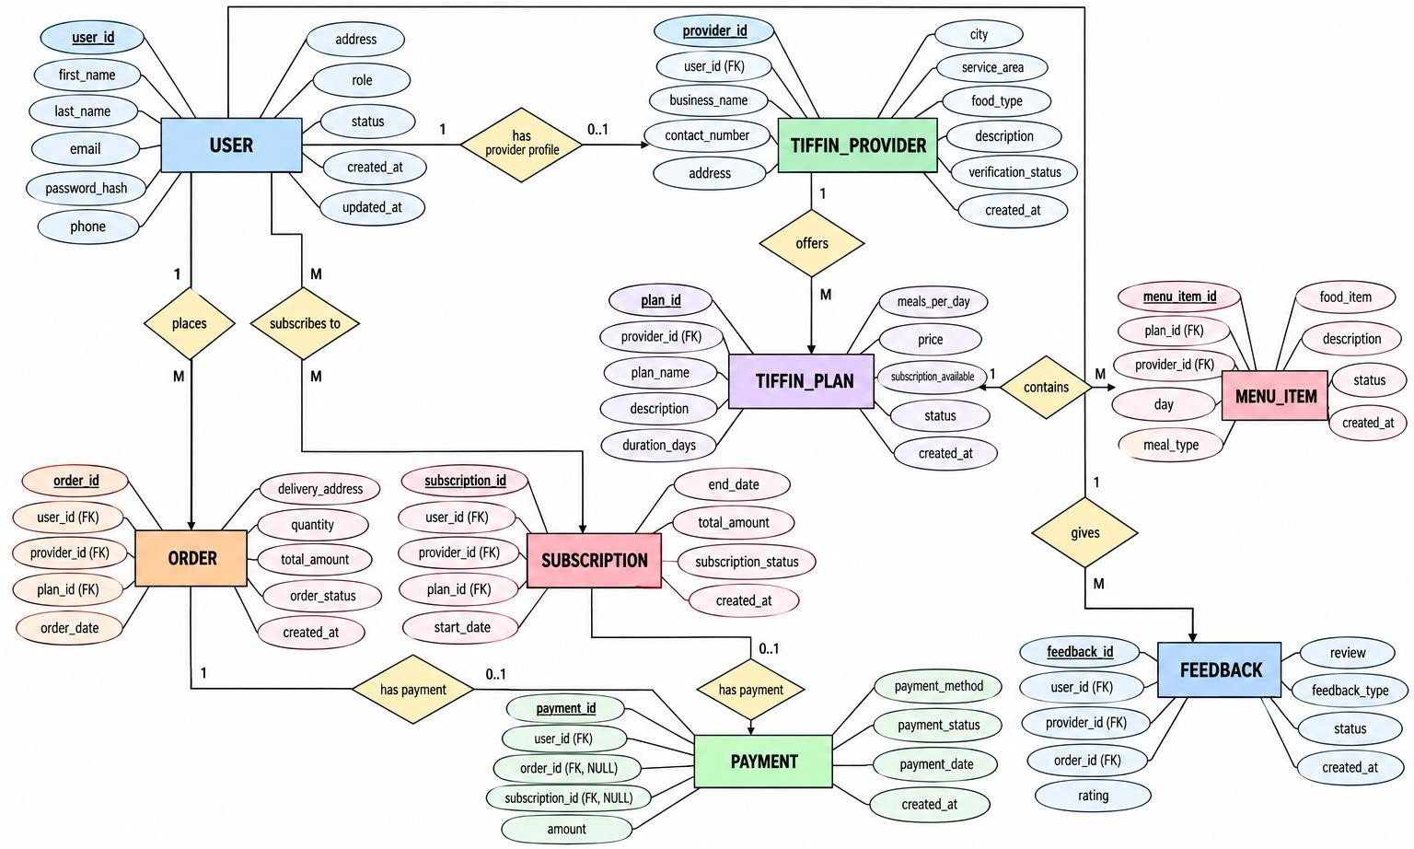
ER-DIAGRAM


DICTIONARY

DATA

1. USER_TABLE

This will contain the common account/authentication information for Admin, Customer, and Tiffin Service Provider.

ATTRIBUTE | CONSTRAINT | DATATYPE | SIZE | DESCRIPTION
USER_ID | PRIMARY_KEY | INT | 15 | Unique identifier for every system user
FIRST_NAME | NOT_NULL | VARCHAR | 50 | First name of the user
LAST_NAME | NULL | VARCHAR | 50 | Last name of the user
EMAIL | NOT_NULL, UNIQUE | VARCHAR | 100 | Email address used for the account
PHONE | NOT_NULL, UNIQUE | VARCHAR | 15 | Contact number of the user
PASSWORD_HASH | NOT_NULL | VARCHAR | 255 | Encrypted/hashed password of the user
ROLE | NOT_NULL | VARCHAR | 20 | Defines user role: ADMIN,  CUSTOMER, or PROVIDER
STATUS | NOT_NULL | VARCHAR | 20 | Account status such as ACTIVE, INACTIVE, or SUSPENDED
CREATED_AT | NOT_NULL | DATETIME | — | Date and time when the account was  created
UPDATED_AT | NULL | DATETIME | — | Date and time when the account was last updated

2. TIFFIN_PROVIDER_TABLE

Stores the business/profile information of a Tiffin Service Provider.

ATTRIBUTE | CONSTRAINT | DATATYPE | SIZE | DESCRIPTION
PROVIDER_ID | PRIMARY_KEY | INT | 15 | Unique identifier for every tiffin service provider
USER_ID | FOREIGN_KEY, UNIQUE | INT | 15 | Maps the provider to the USER table
BUSINESS_NAME | NOT_NULL | VARCHAR | 100 | Name of the tiffin service/business
CONTACT_NUMBER | NOT_NULL | VARCHAR | 15 | Contact number of the service provider
ADDRESS | NOT_NULL | VARCHAR | 255 | Address of the tiffin service provider
CITY | NOT_NULL | VARCHAR | 50 | City where the service operates
SERVICE_AREA | NOT_NULL | VARCHAR | 255 | Area or locations where tiffin service is provided
FOOD_TYPE | NULL | VARCHAR | 50 | Type/category of food offered
DESCRIPTION | NULL | VARCHAR | 500 | Description of the tiffin service
VERIFICATION_STATUS | NOT_NULL | VARCHAR | 20 | Provider verification status such as PENDING, VERIFIED, or REJECTED
CREATED_AT | NOT_NULL | DATETIME | — | Date and time when provider profile was created

3. TIFFIN_PLAN_TABLE

Stores the different plans/packages offered by a Tiffin Service Provider.

ATTRIBUTE | CONSTRAINT | DATATYPE | SIZE | DESCRIPTION
PLAN_ID | PRIMARY_KEY | INT | 15 | Unique identifier for each tiffin plan
PROVIDER_ID | FOREIGN_KEY | INT | 15 | Maps the plan to the TIFFIN_PROVIDER table
PLAN_NAME | NOT_NULL | VARCHAR | 100 | Name of the tiffin plan
DESCRIPTION | NOT_NULL | VARCHAR | 500 | Description of the plan
DURATION_DAYS | NOT_NULL | INT | 5 | Number of days covered by the plan
MEALS_PER_DAY | NOT_NULL | INT | 2 | Number of meals provided per day
PRICE | NOT_NULL | DECIMAL | 10,2 | Price of the tiffin plan
SUBSCRIPTION_AVAILABLE | NOT_NULL | BOOLEAN | 1 | Indicates whether the plan supports subscription
STATUS | NOT_NULL | VARCHAR | 20 | Plan status such as ACTIVE or INACTIVE
CREATED_AT | NOT_NULL | DATETIME | — | Date and time when the plan was created

4. MENU_ITEM_TABLE

Stores the food/menu items offered under a tiffin plan.

ATTRIBUTE | CONSTRAINT | DATATYPE | SIZE | DESCRIPTION
MENU_ITEM_ID | PRIMARY_KEY | INT | 15 | Unique identifier for each menu item
PLAN_ID | FOREIGN_KEY | INT | 15 | Maps the menu item to the TIFFIN_PLAN table
PROVIDER_ID | FOREIGN_KEY | INT | 15 | Maps the menu item to the  TIFFIN_PROVIDER table
DAY_OF_WEEK | NOT_NULL | VARCHAR | 15 | Day on which the menu item is served
MEAL_TYPE | NOT_NULL | VARCHAR | 20 | Type of meal such as Breakfast, Lunch, or Dinner
ITEM_NAME | NOT_NULL | VARCHAR | 100 | Name of the food item
DESCRIPTION | NULL | VARCHAR | 255 | Description of the food item
STATUS | NOT_NULL | VARCHAR | 20 | Status of the menu item such as ACTIVE or INACTIVE
CREATED_AT | NOT_NULL | DATETIME | — | Date and time when the menu item was added

5. ORDER_TABLE

Stores one-time orders placed by customers.

ATTRIBUTE | CONSTRAINT | DATATYPE | SIZE | DESCRIPTION
ORDER_ID | PRIMARY_KEY | INT | 15 | Unique identifier for each order
CUSTOMER_ID | FOREIGN_KEY | INT | 15 | Maps the order to the customer in USER table
PROVIDER_ID | FOREIGN_KEY | INT | 15 | Maps the order to the tiffin service provider
PLAN_ID | FOREIGN_KEY | INT | 15 | Maps the order to the selected tiffin plan
ORDER_DATE | NOT_NULL | DATETIME | — | Date and time when the order was placed
QUANTITY | NOT_NULL | INT | 5 | Number of tiffin units ordered
DELIVERY_ADDRESS | NOT_NULL | VARCHAR | 255 | Address where the order should be delivered
TOTAL_AMOUNT | NOT_NULL | DECIMAL | 10,2 | Total amount payable for the order
ORDER_STATUS | NOT_NULL | VARCHAR | 20 | Order status such as PENDING, ACCEPTED, REJECTED, COMPLETED, or CANCELLED
CREATED_AT | NOT_NULL | DATETIME | — | Date and time when the order record was created

6. SUBSCRIPTION_TABLE

Stores customer subscriptions to recurring tiffin plans.

ATTRIBUTE | CONSTRAINT | DATATYPE | SIZE | DESCRIPTION
SUBSCRIPTION_ID | PRIMARY_KEY | INT | 15 | Unique identifier for each  subscription
CUSTOMER_ID | FOREIGN_KEY | INT | 15 | Maps the subscription to the customer
PROVIDER_ID | FOREIGN_KEY | INT | 15 | Maps the subscription to the tiffin service provider
PLAN_ID | FOREIGN_KEY | INT | 15 | Maps the subscription to the selected tiffin plan
START_DATE | NOT_NULL | DATE | 10 | Date on which the subscription starts
END_DATE | NOT_NULL | DATE | 10 | Date on which the subscription ends
TOTAL_AMOUNT | NOT_NULL | DECIMAL | 10,2 | Total amount of the subscription
AUTO_RENEWAL | NOT_NULL | BOOLEAN | 1 | Indicates whether the subscription  automatically renews
SUBSCRIPTION_STATUS | NOT_NULL | VARCHAR | 20 | Status such as ACTIVE, EXPIRED, or CANCELLED
CREATED_AT | NOT_NULL | DATETIME | — | Date and time when the subscription was created

7. PAYMENT_TABLE

Stores payment information for customer orders and subscriptions.

ATTRIBUTE | CONSTRAINT | DATATYPE | SIZE | DESCRIPTION
PAYMENT_ID | PRIMARY_KEY | INT | 15 | Unique identifier for each payment
CUSTOMER_ID | FOREIGN_KEY | INT | 15 | Maps the payment to the customer
ORDER_ID | FOREIGN_KEY, NULL | INT | 15 | Maps payment to an order when payment is for a one-time order
SUBSCRIPTION_ID | FOREIGN_KEY, NULL | INT | 15 | Maps payment to a subscription when payment is for a subscription
TRANSACTION_ID | NOT_NULL, UNIQUE | VARCHAR | 100 | Unique transaction/reference number generated for the payment
AMOUNT | NOT_NULL | DECIMAL | 10,2 | Amount paid by the customer
PAYMENT_METHOD | NOT_NULL | VARCHAR | 30 | Payment method such as Card, UPI, or Net Banking
PAYMENT_STATUS | NOT_NULL | VARCHAR | 20 | Payment status such as PENDING, SUCCESS, or FAILED
PAYMENT_DATE | NOT_NULL | DATETIME | — | Date and time when payment was made

8. FEEDBACK_TABLE

Stores customer feedback, ratings, and complaints related to the tiffin service.

ATTRIBUTE | CONSTRAINT | DATATYPE | SIZE | DESCRIPTION
FEEDBACK_ID | PRIMARY_KEY | INT | 15 | Unique identifier for each feedback record
CUSTOMER_ID | FOREIGN_KEY | INT | 15 | Maps feedback to the customer
PROVIDER_ID | FOREIGN_KEY | INT | 15 | Maps feedback to the tiffin service provider
ORDER_ID | FOREIGN_KEY | NULL | INT | 15
RATING | NOT_NULL | DECIMAL | 2,1 | Rating given by the customer
REVIEW | NULL | VARCHAR | 500 | Written feedback or review from the customer
FEEDBACK_TYPE | NOT_NULL | VARCHAR | 20 | Type such as FEEDBACK or COMPLAINT
STATUS | NOT_NULL | VARCHAR | 20 | Status such as OPEN, REVIEWED, or RESOLVED
CREATED_AT | NOT_NULL | DATETIME | — | Date and time when feedback was submitted

